Lab Exercise 7
Integrating Maven with Jenkins

Name-Garvit janu Batch- 3 (DevOps) SAP ID-500119646

Objective: To install the Maven plugin in Jenkins for smooth integration and automation of
Maven-based build processes within the Jenkins environment

Tools required: Git, GitHub, and Jenkins

Prerequisites: None

Step 1: Install the Maven plugin

1.1 Open the browser, go to the Jenkins Dashboard by typing localhost:8080 in your browser, provide the credentials, and click the Sign in button

1.2 Click on the Manage Jenkins option as shown in the screenshot below:
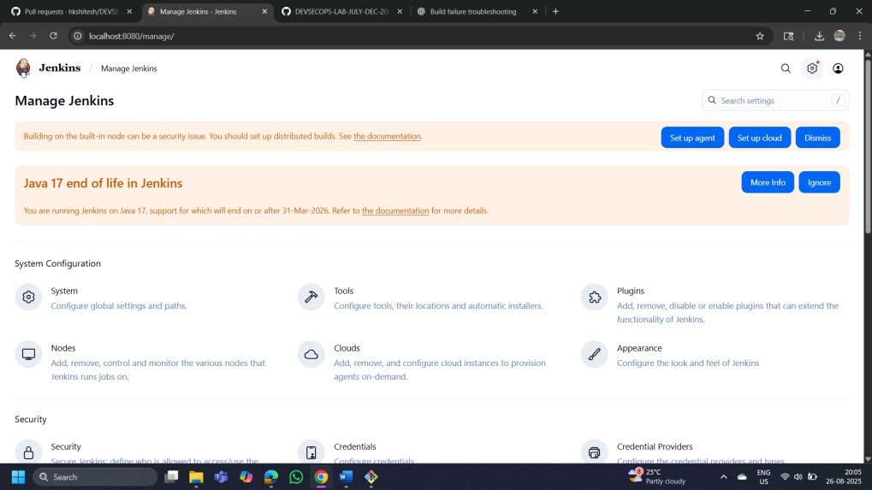

1.3 Click on the Plugins option as shown in the screenshot below:
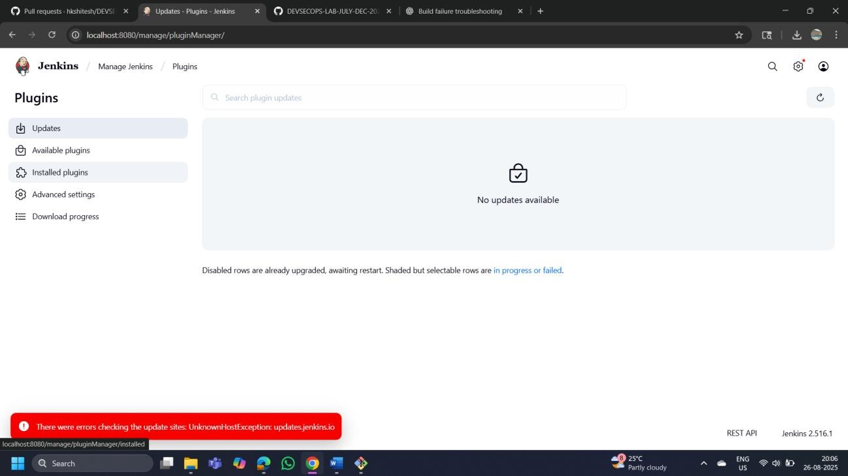

1.4 Click on Installed plugins to verify whether the Maven Integration plugin has been installed
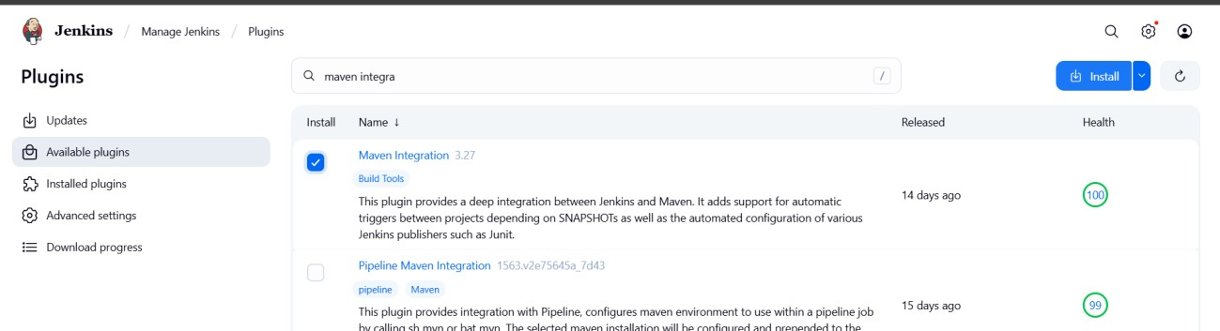

(My plugin of MAVEN was not installed so installed it)
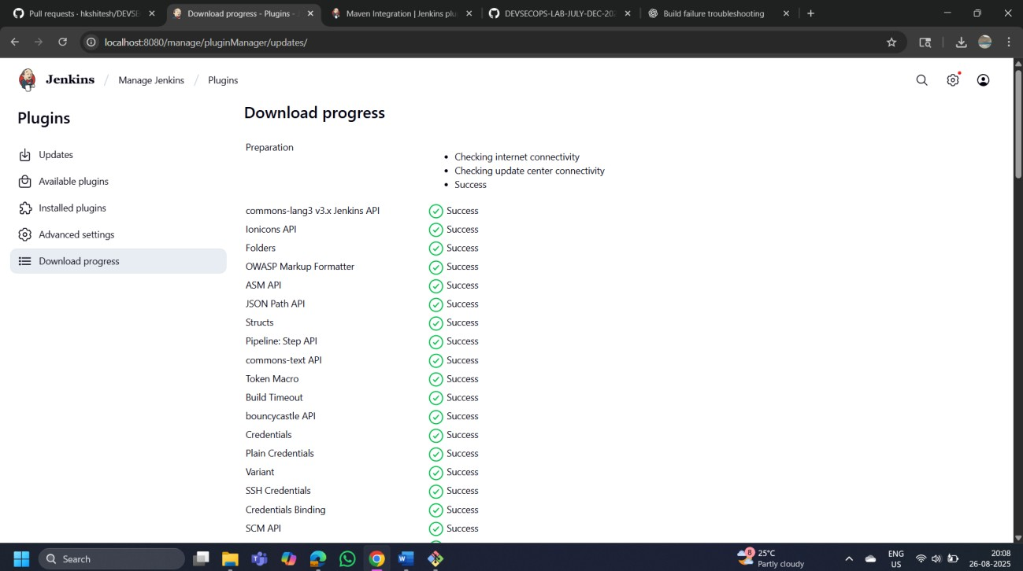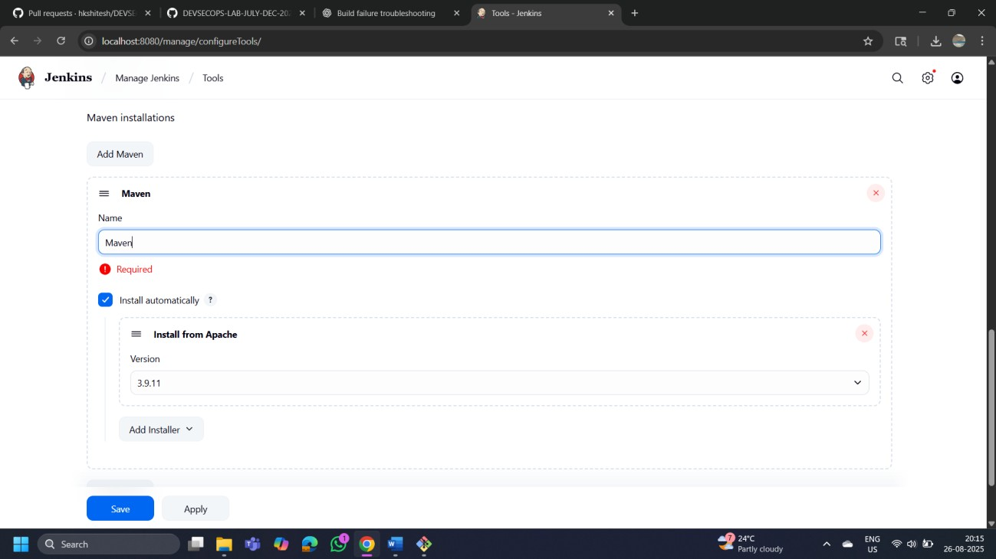

1.5 Use the following command to check the Maven version:
mvn -version

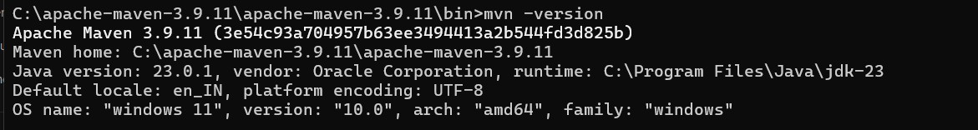

Step 2: Set up Global Tool Configuration

2.1 Go to the Jenkins Dashboard, click on Manage Jenkins, and then select Tools from the list of options\

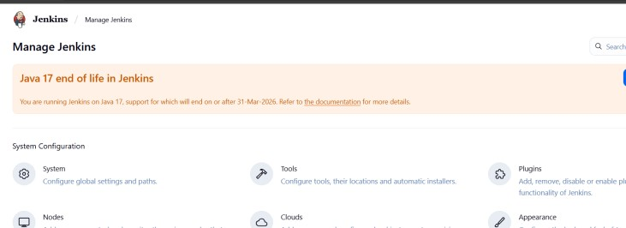

2.2 To configure Maven, click on the Maven installations button in the Maven section and enter a Name and MAVEN_HOME path
